FORMAT FOR SUBMISSION OF ‘NANOTECH HACKATHON’ PROJECT
(INUP-i2i), IIT Bombay
Indian Nanoelectronics Users’ Program - Idea to Innovation
(To be filled by the applicant. The font size should not be smaller than 10 point. Proposals exceeding 10 pages would be rejected without consideration.)
- Project Title

- Area of Research

- Duration in months (Maximum :6 months) -

- Investigator(s)
 | Participant 1 | Participant 2 | Participant 3
Title and Name
Designation
Department
Organization
Academic
Government/private
Address
Telephone
Telefax
e-mail
- Project abstract (maximum 150 words)

- Key words (maximum 6)

- Technical details (maximum 4 pages)
  - Introduction (including literature review illustrating the state of the art and clear statement of the relevance of the proposal)

  - Definition of the problem
Research methodology (clearly state the methodology proposed for investigating the problem. Give a detailed step-wise process flow; please refer MOSCAP fabrication)

  - Application of the proposed device

  - Elaborate on how would the proposed device address the societal needs

  - List of references

- Work plan
  - Time schedule of activities giving milestones in a bar diagram (an example is shown below)
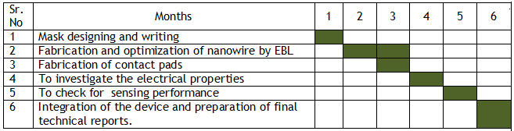
  - End usage of the research outcome

  - Suggested plan of action for utilization of research outcome expected from the project

- Consumables Required
List the consumables (wafers, gases, liquid chemicals, metal targets etc) required for the project and approximate quantities. No cost information to be filled up by the proposer. This information would assist the INUP personnel at IIT Bombay to provide your special requirements in a timely manner.
- Research infrastructure required
  - List those required from IITBNF
(Details of R&D infrastructure available at the IITBNF may be found on Equipment Status)
  - List those available in your organization, if any, for the proposed project.

- If the fabrication process involves steps from outside IITBNF, please submit the outside sample history form Outside sample history & process request_INUP.docx

